**ORM / Web Services Midterm Project**

# **Topic: Article Post**

## **Instructor: LYPENGLEANG SEANG**

### **Group 5 members:**

* CHEA CHAN
* CHEA DEVIT
* NEAM SINAT

**University of Puthisastra**

1. **Week 1**

What is the project?

=> The project is the Article Post, it provides the news and articles within Entertainment, Sports, Technologies and Socials news.

Why did we choose this topic?

=> We choose the project because we want all the people to get the new information and knowledge easier than watching TV, because they just use the pc or smartphone to access the platform and they can see all the information and it is also included in the entertainment news to make people happy.

What is our goal of making this happen?

=> Our Goal: This website will provide the user the best experience well with the new information.

How does my team build this platform?

=> Basically, we are built this website from scratch with the web technology

First we start to defined this project and discuss with our team decide to choose the project and we all consider to choose Article post, and then we defined the project scope, and after that we start with the front-end technologies within HTML+CSS+JAVASCRIPT, Bootstrap, and then dividing the task to our team member,

For our backend project we see a lot of the technology, and we all know about the laravel framework and MySQL so we decided to choose this technology.

Here is our features:

=> Admin

* Login Page
* Register Page
* Users
  + List users
  + Delete users
  + Update users
  + View user detail
* Category
  + List category
  + Delete category
  + Update category
  + View category
* Article
  + List Article
  + Delete Article
  + Update Article
  + View article

=> User

* Home Page
* Entertainment Page
* Sport Page
* Social Page
* Technologies Page

1. **Week 2**

* **Team**:
* Analyst and Database Design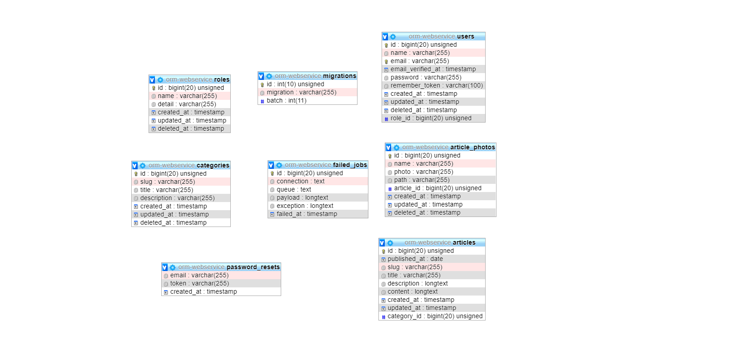
* **Chea Devit:**
* Init project and push project to github
* Database migration => Create database seeder => User admin, category and create faker data for article list & CRUD article

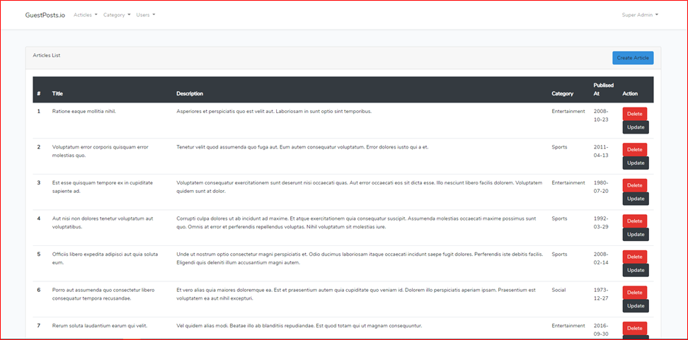

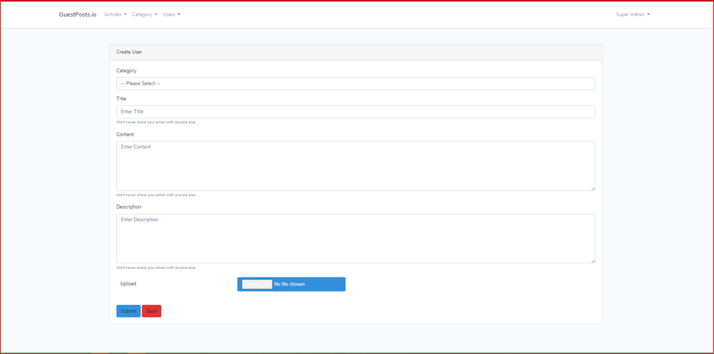

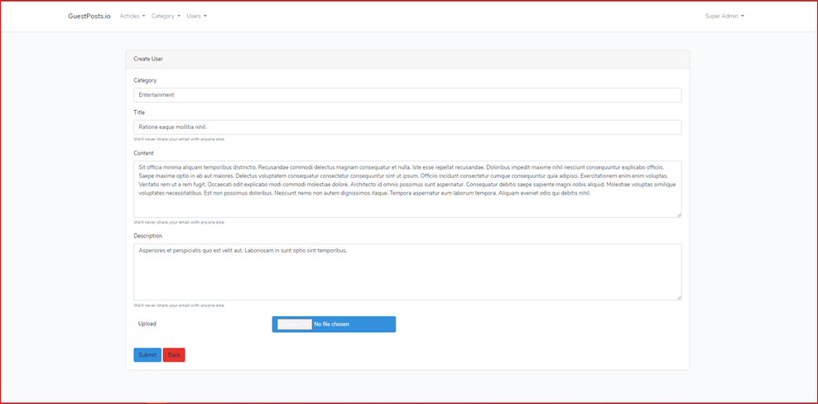

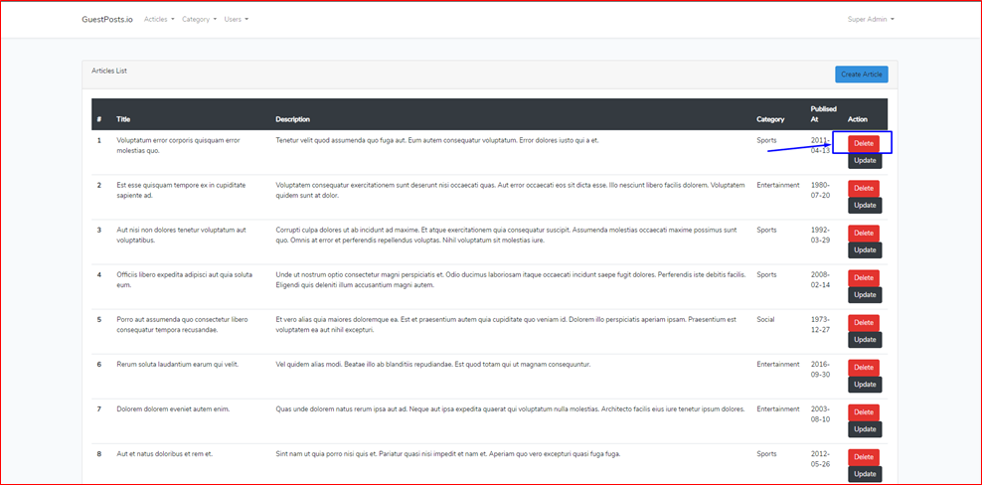

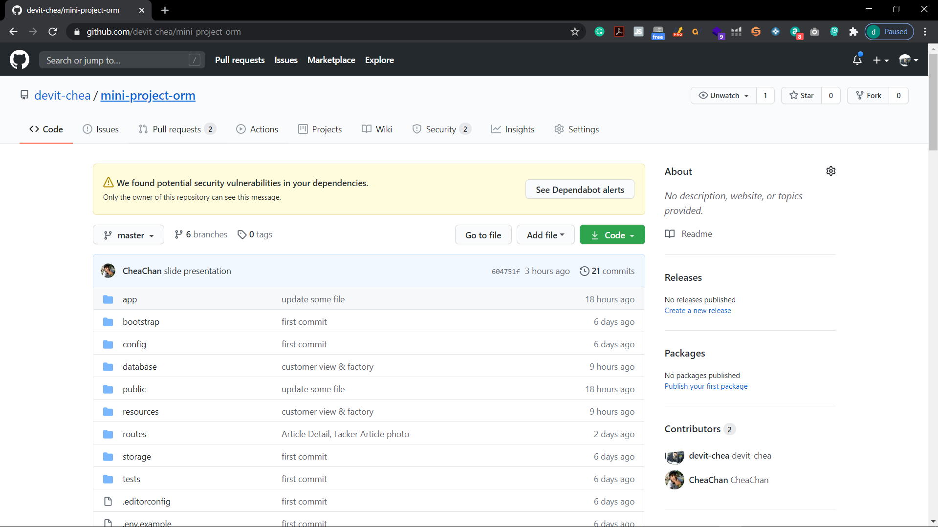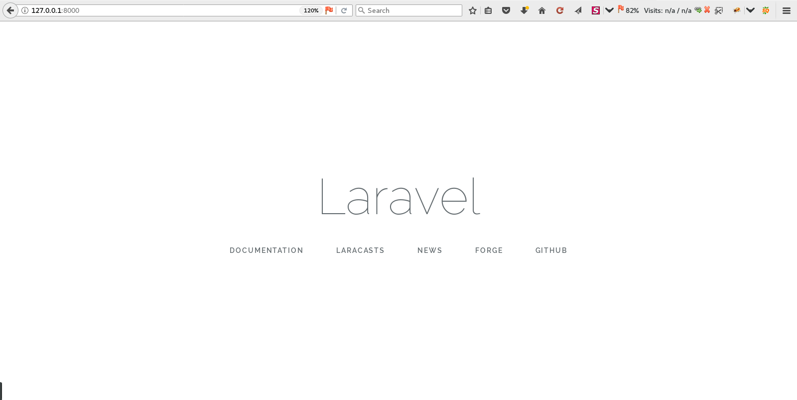

* **Chea Chan**:
* Login & Register & CRUD users

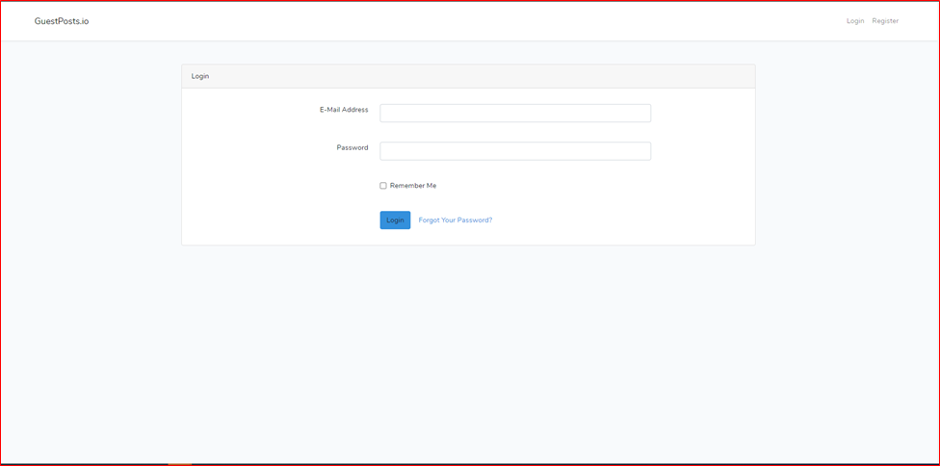

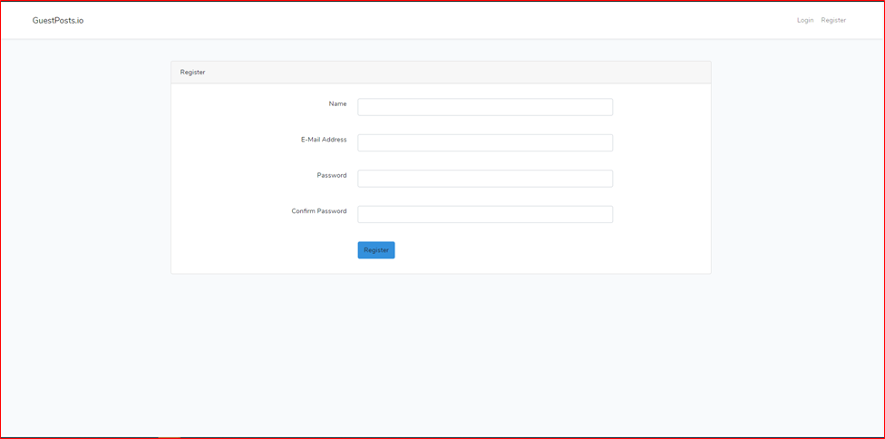

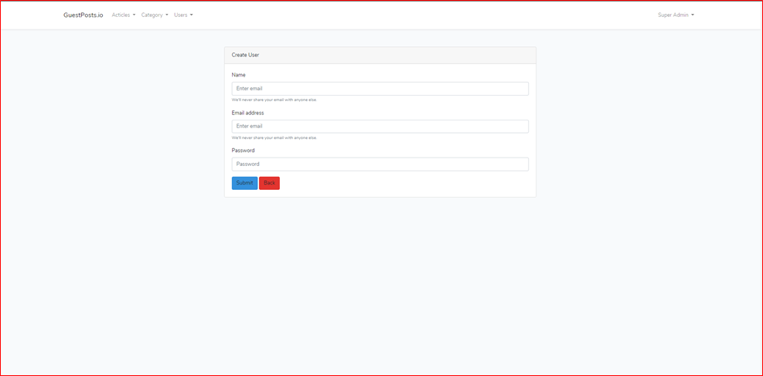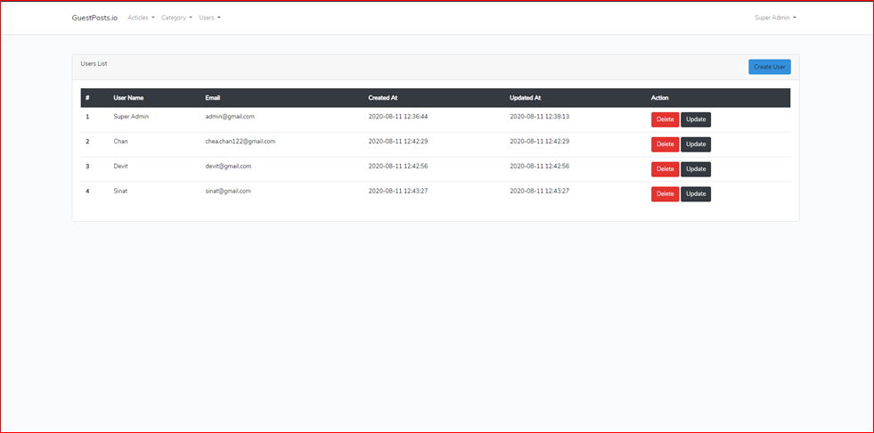

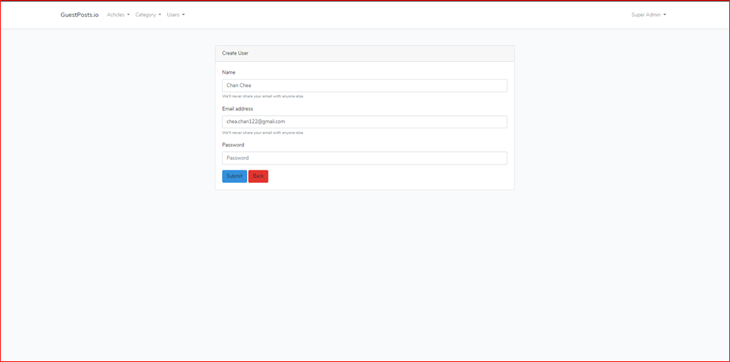

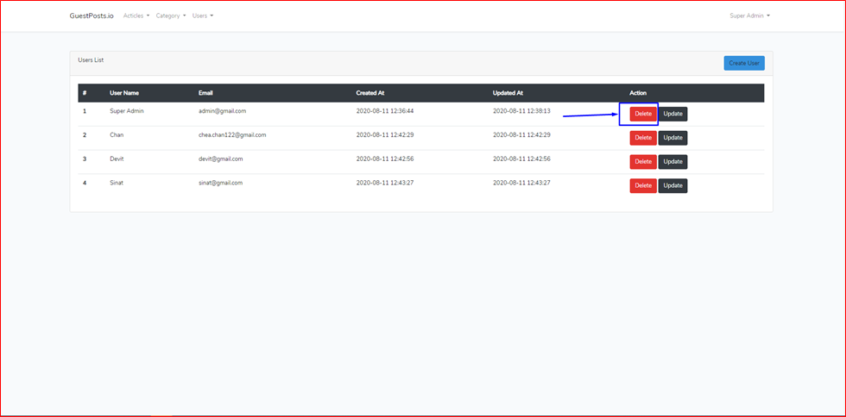

* **Neam Sinat**:
* CRUD category

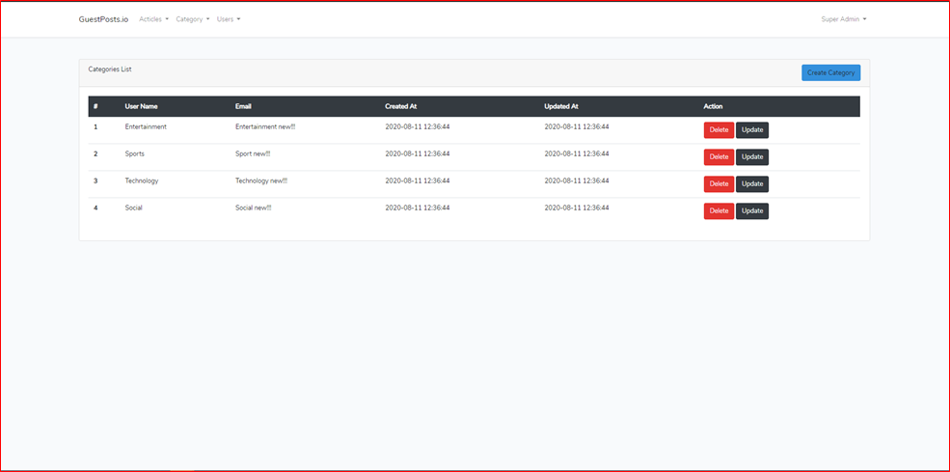

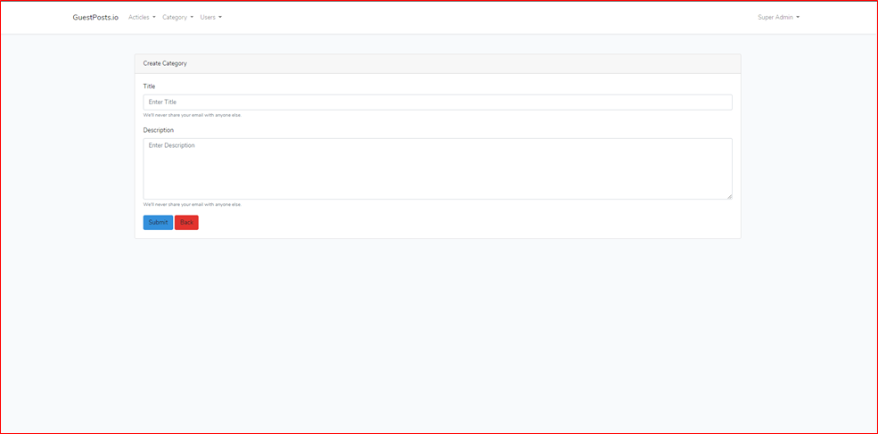

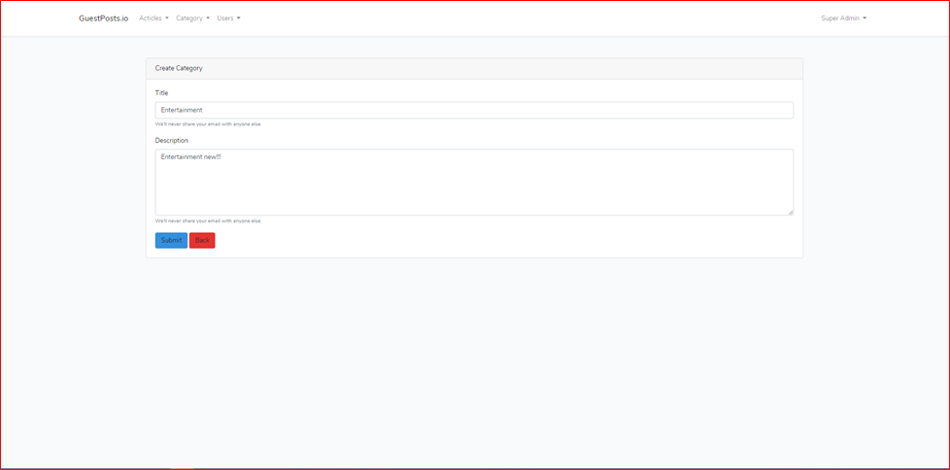

1. **Week 3**

* **Chea Devit**:
* Design articles & entertainment home page and fetch data from database to view

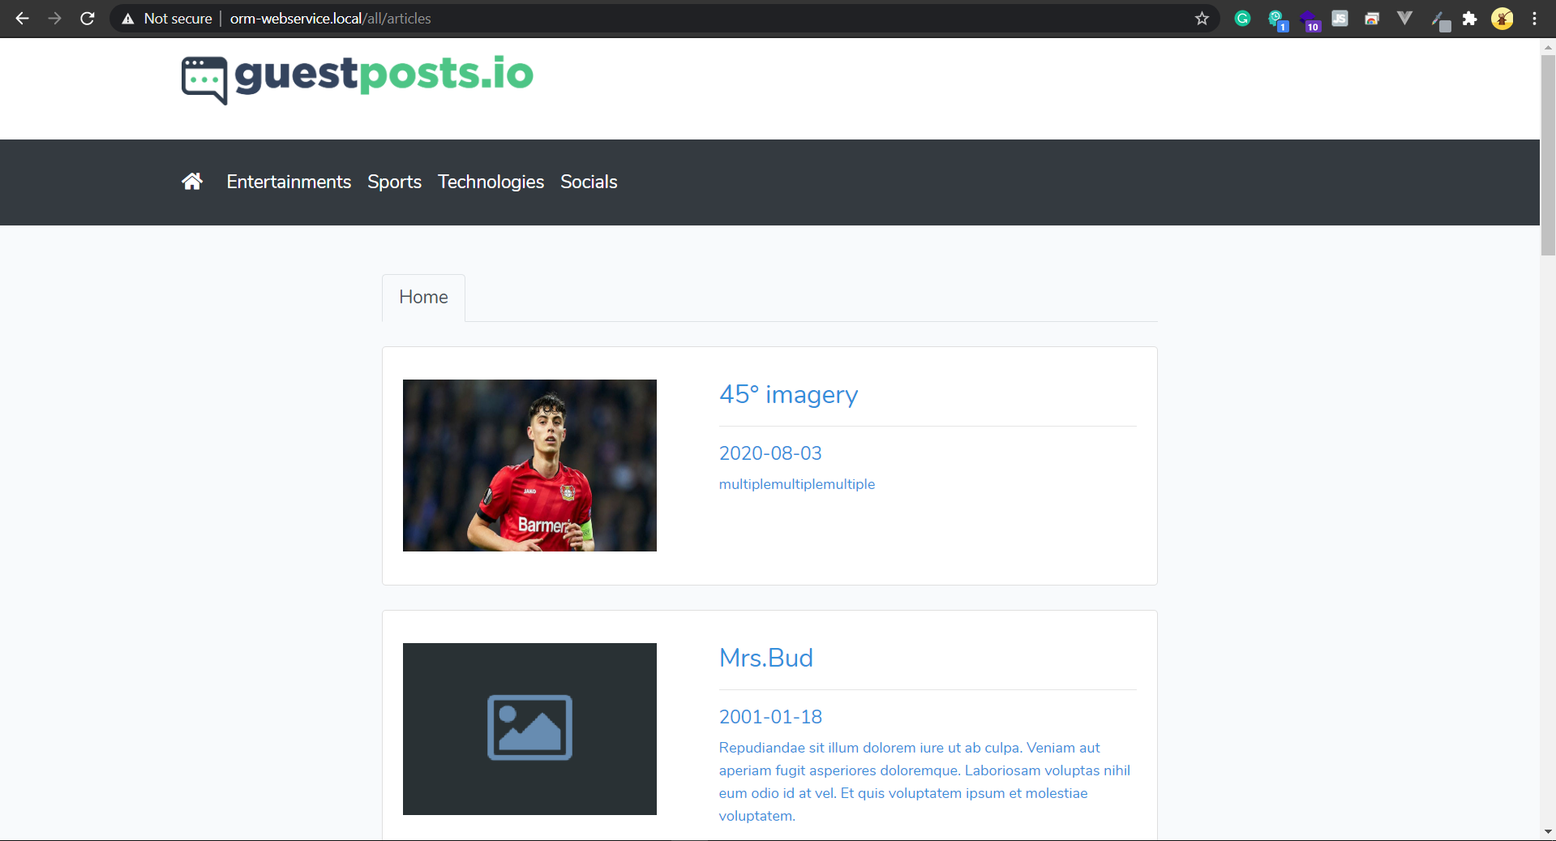

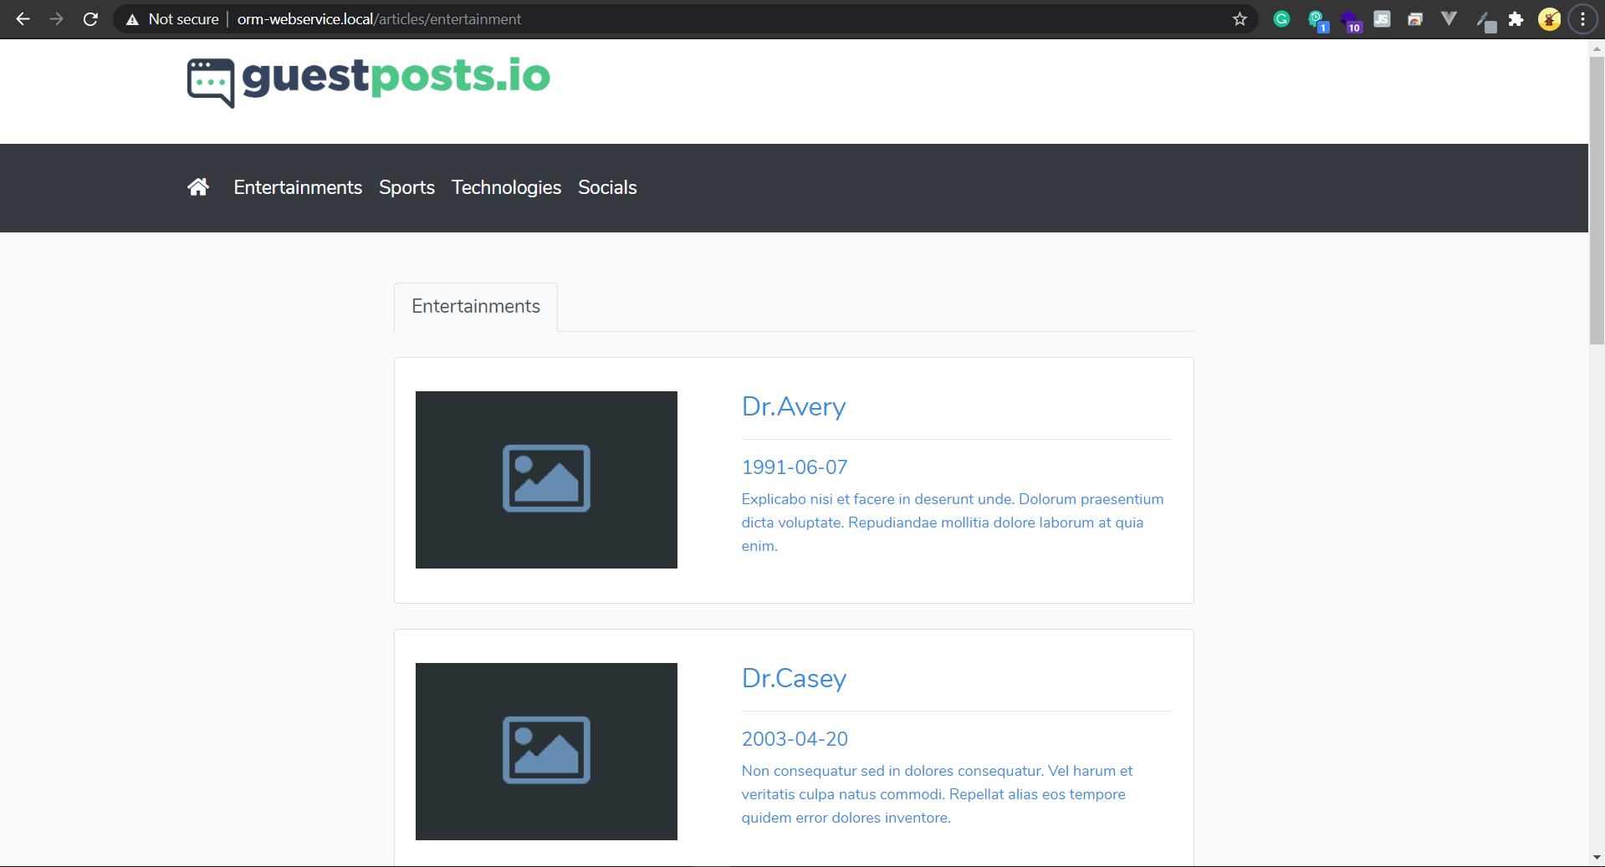

* **Chea Chan**:
* Design Social and Technology page and fetch data from database to view on page

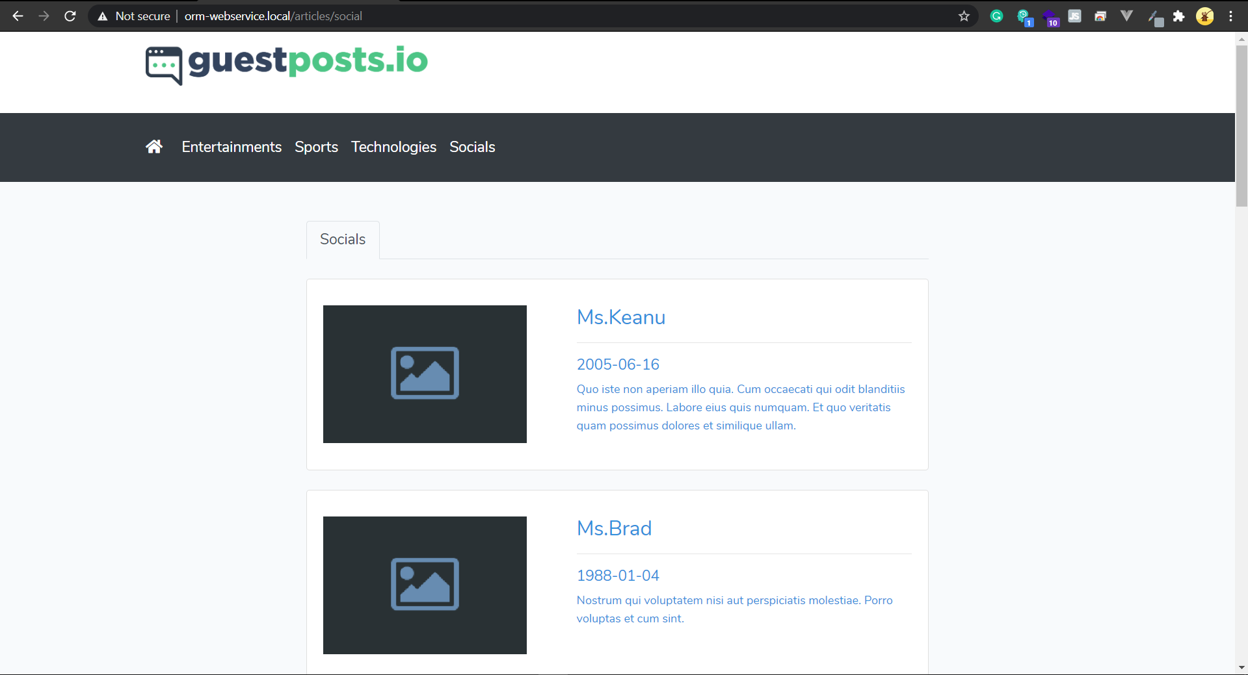

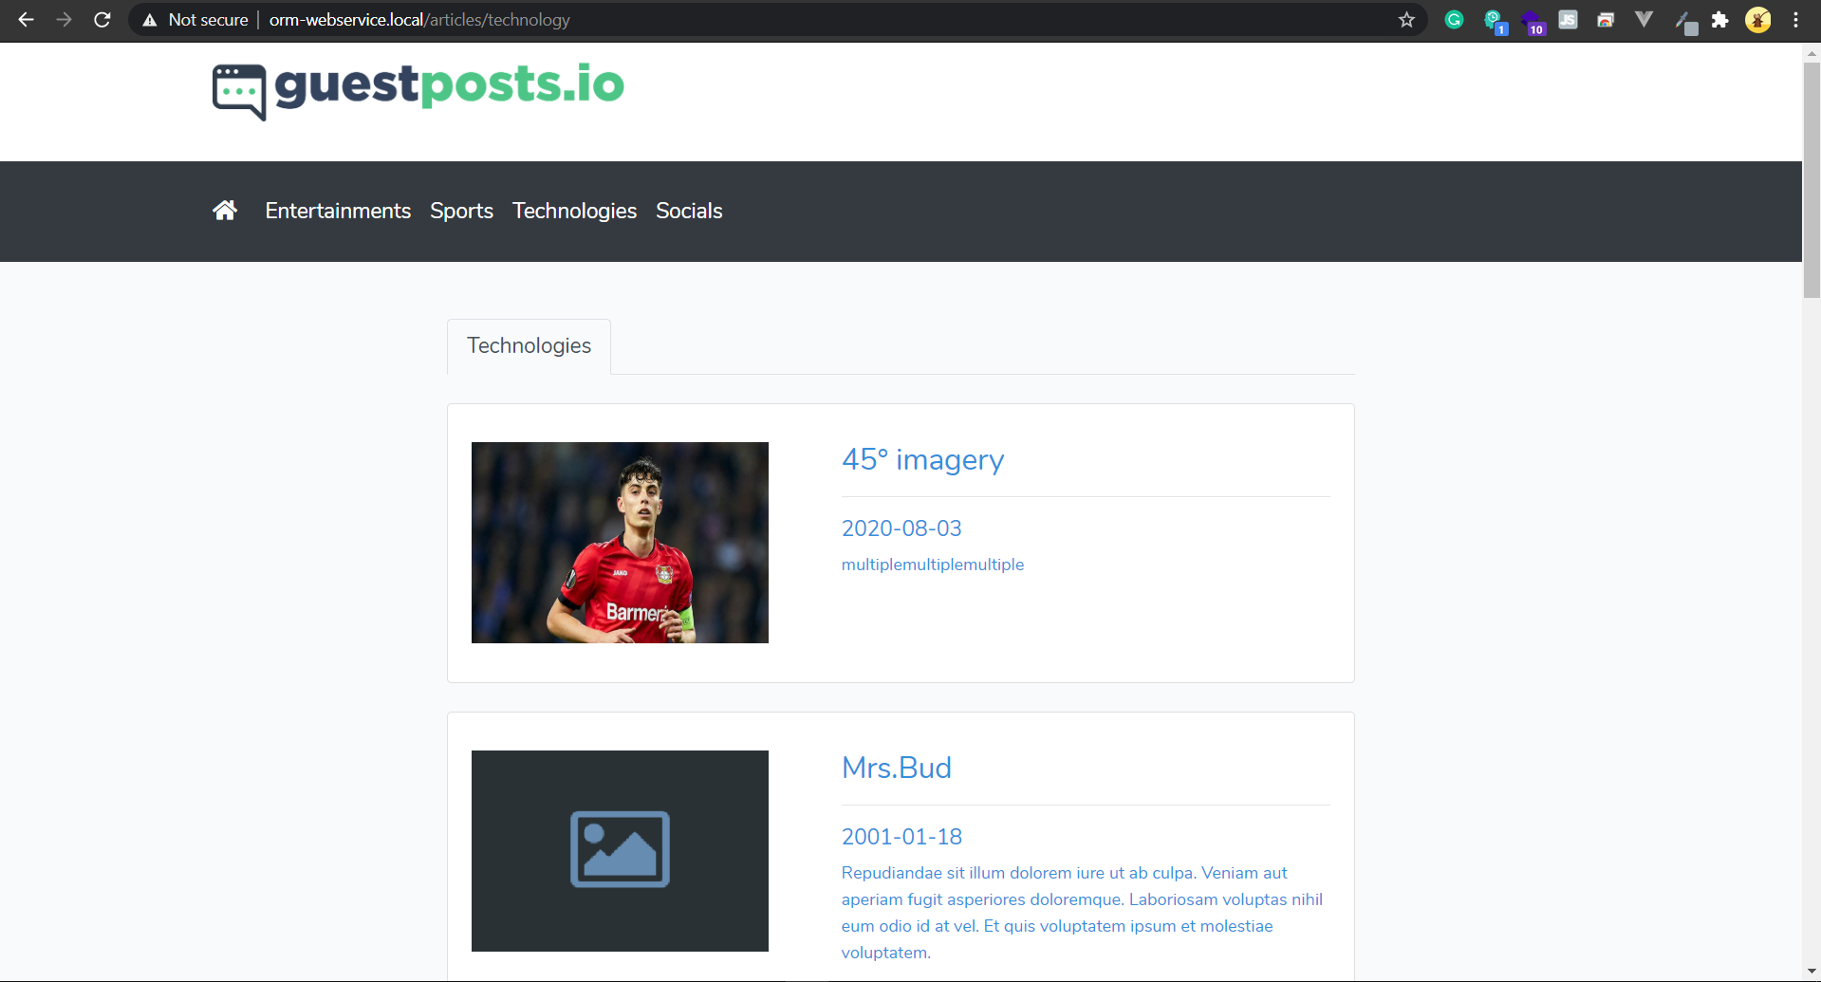

* **Neam Sinat**:
* Design Sport page and fetch data from database to the view

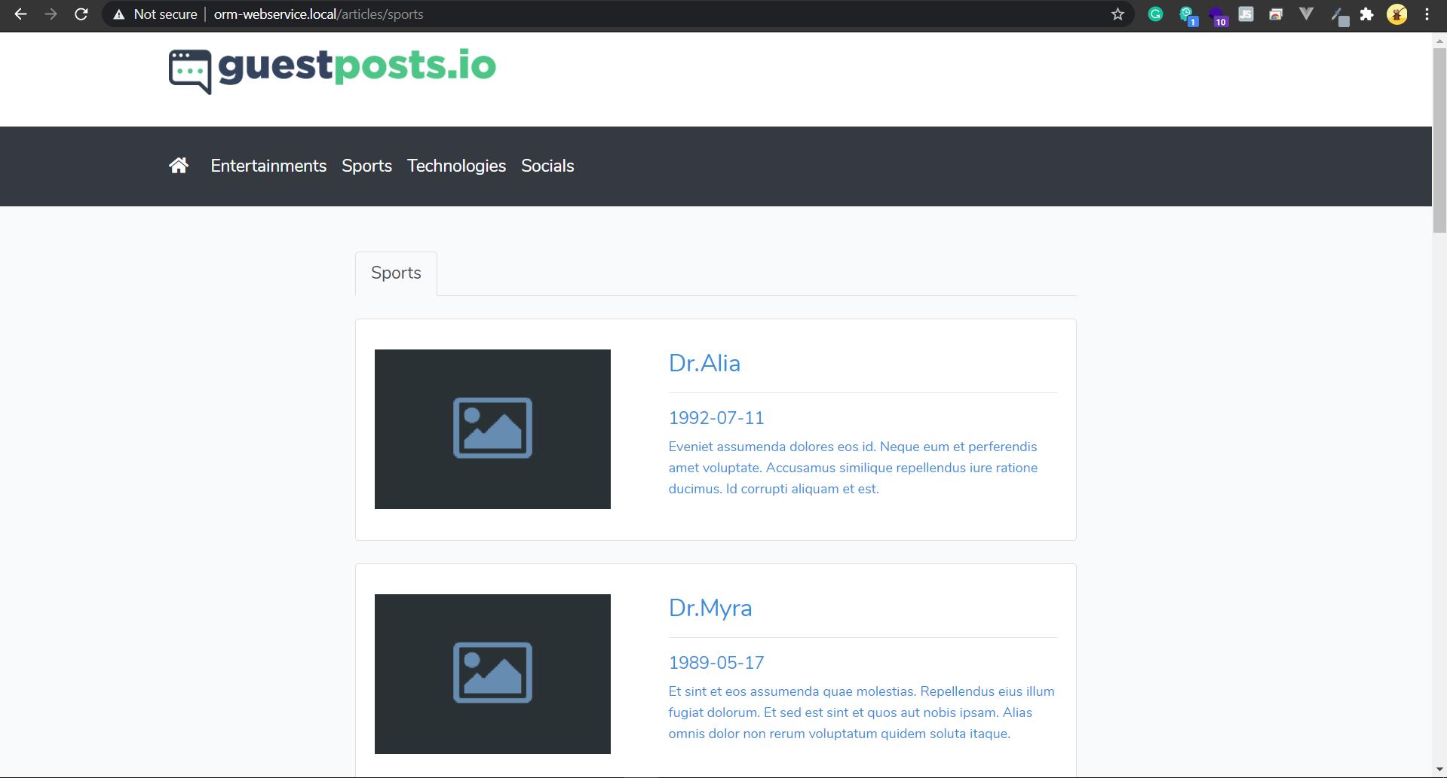

* **Chea Devit**:
* Design Article detail

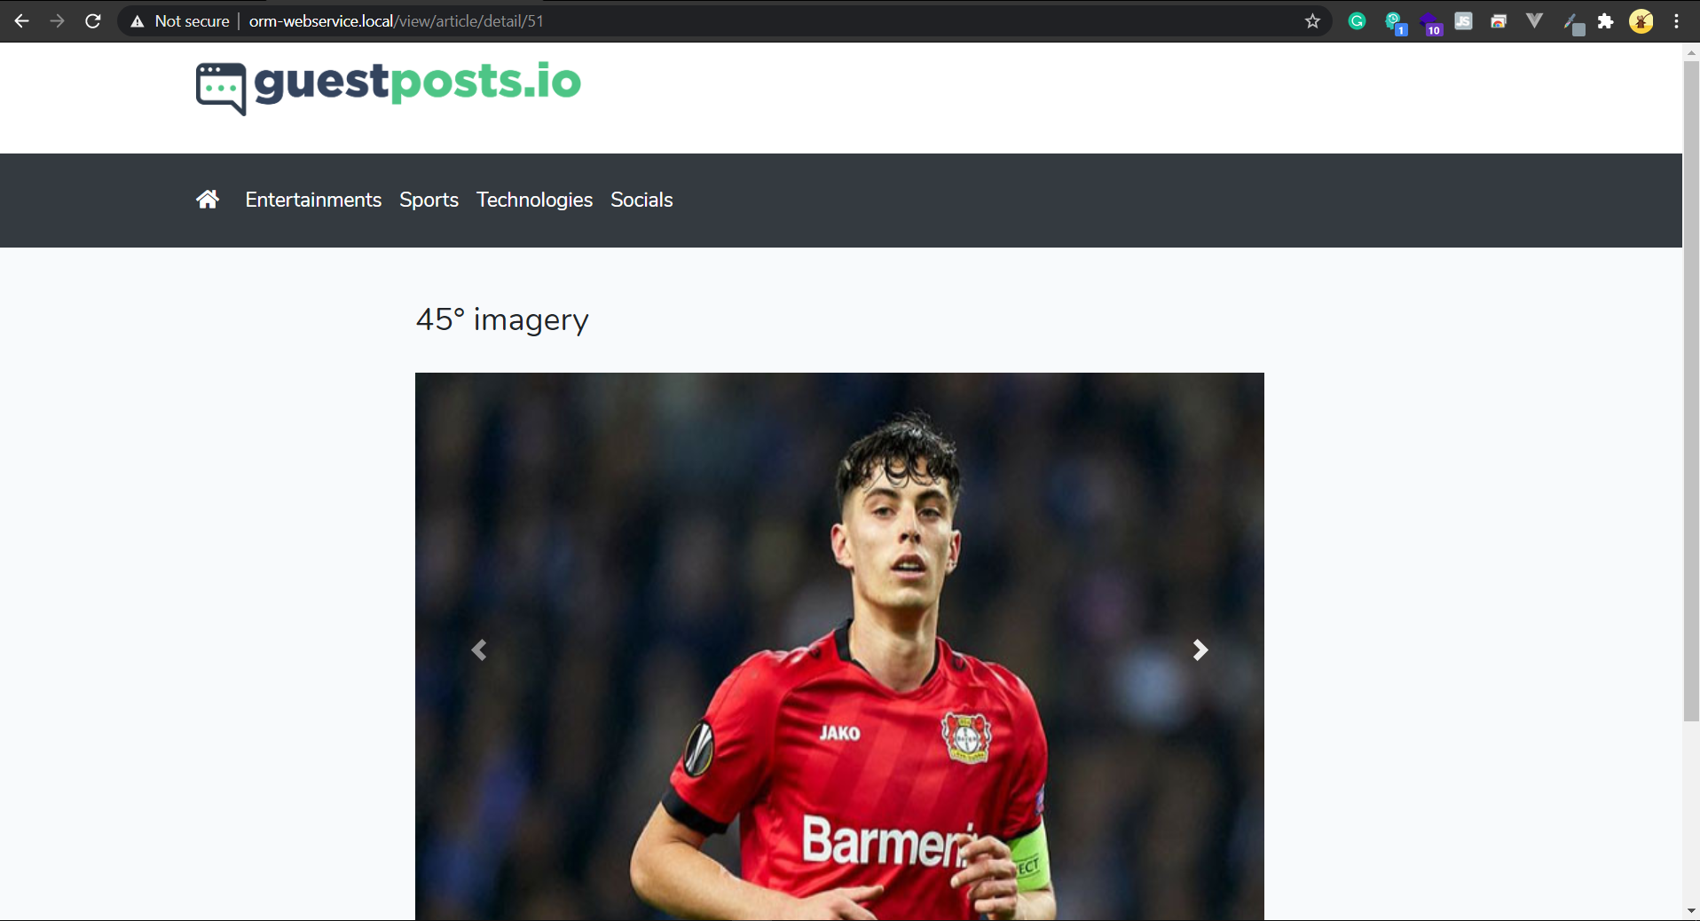

* **Chea Chan**: Add pagination in each list
* **Chea Devit**: Prepare Document Project Report
* **Neam Sinat**: Prepare Slide Presentation
* **Chea Chan**: Add document teacher’s project requirement needed

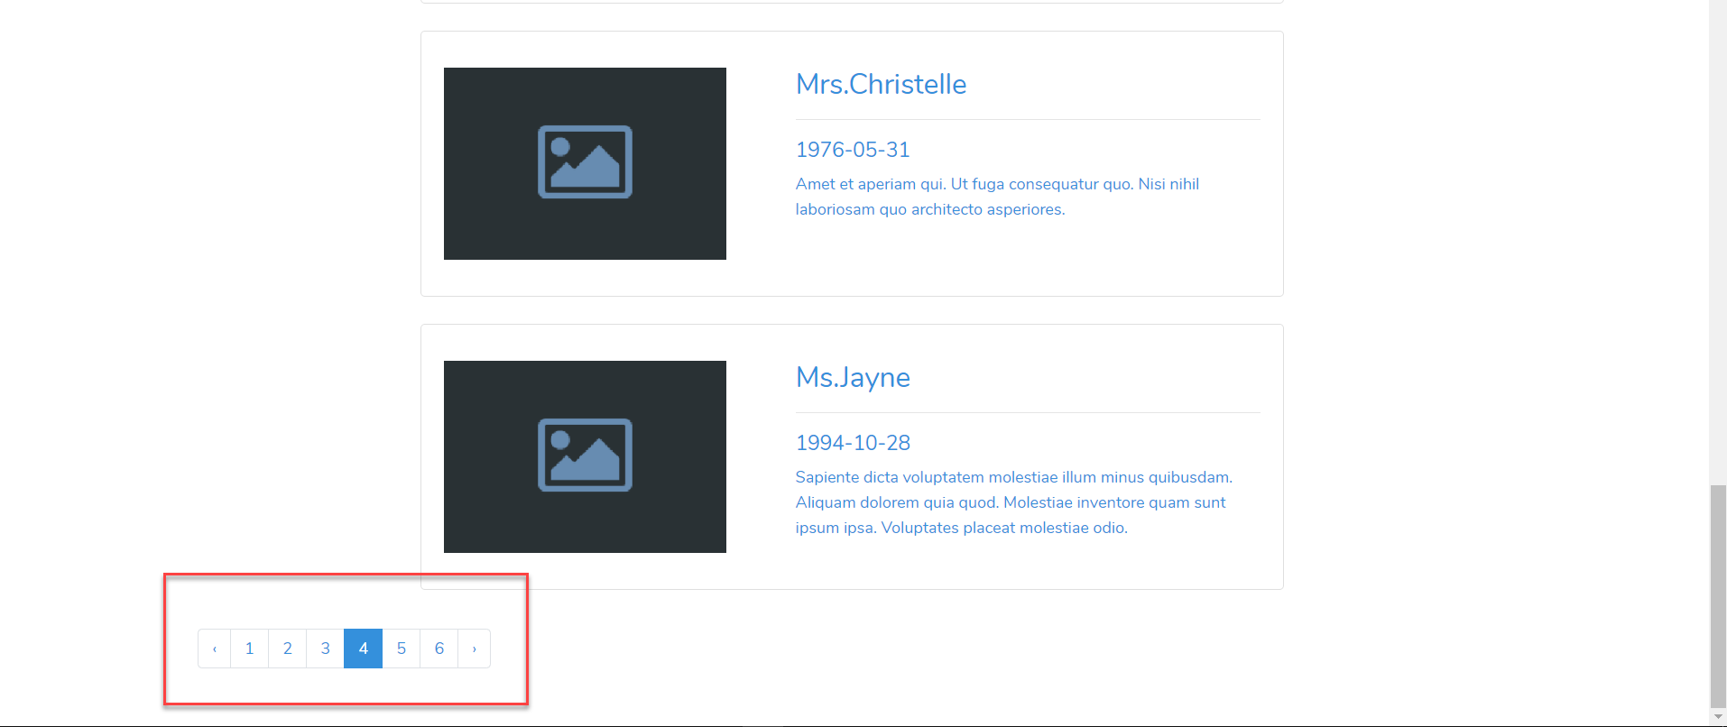

* Push project to the github
* Team meeting before finish
* Close project version 1.0.40

**The best 5 special features in the system**

1. CRUD Users
2. CRUD Article
3. CRUD Category
4. List the article with different categories
5. Article details

Reference: We have no reference because we build our own.